DAA Practicals

Vansh Garg
Bsc (Hons) Computer Science
25821

Q1) Write a program to sort the elements of an array using Insertion Sort (The program
should report the number of comparisons).

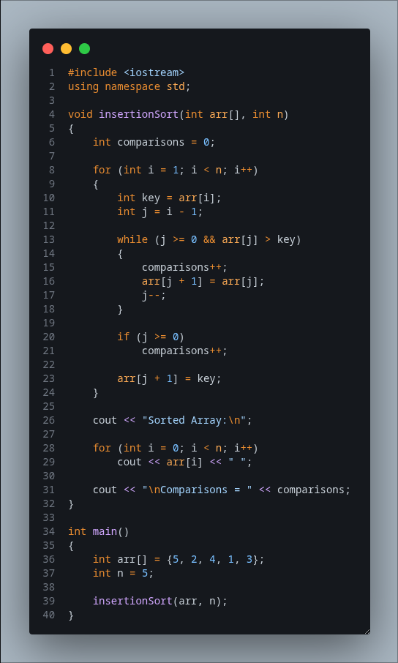

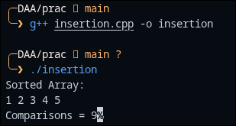

Q2) Write a program to sort the elements of an array using Merge Sort (The program
should report the number of comparisons).

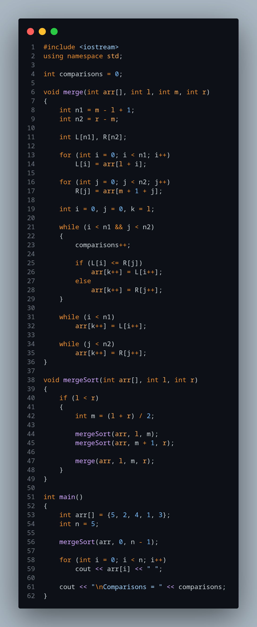

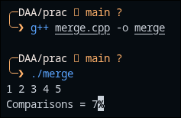

Q3) Write a program to sort the elements of an array using Heap Sort (The program
should report the number of comparisons).

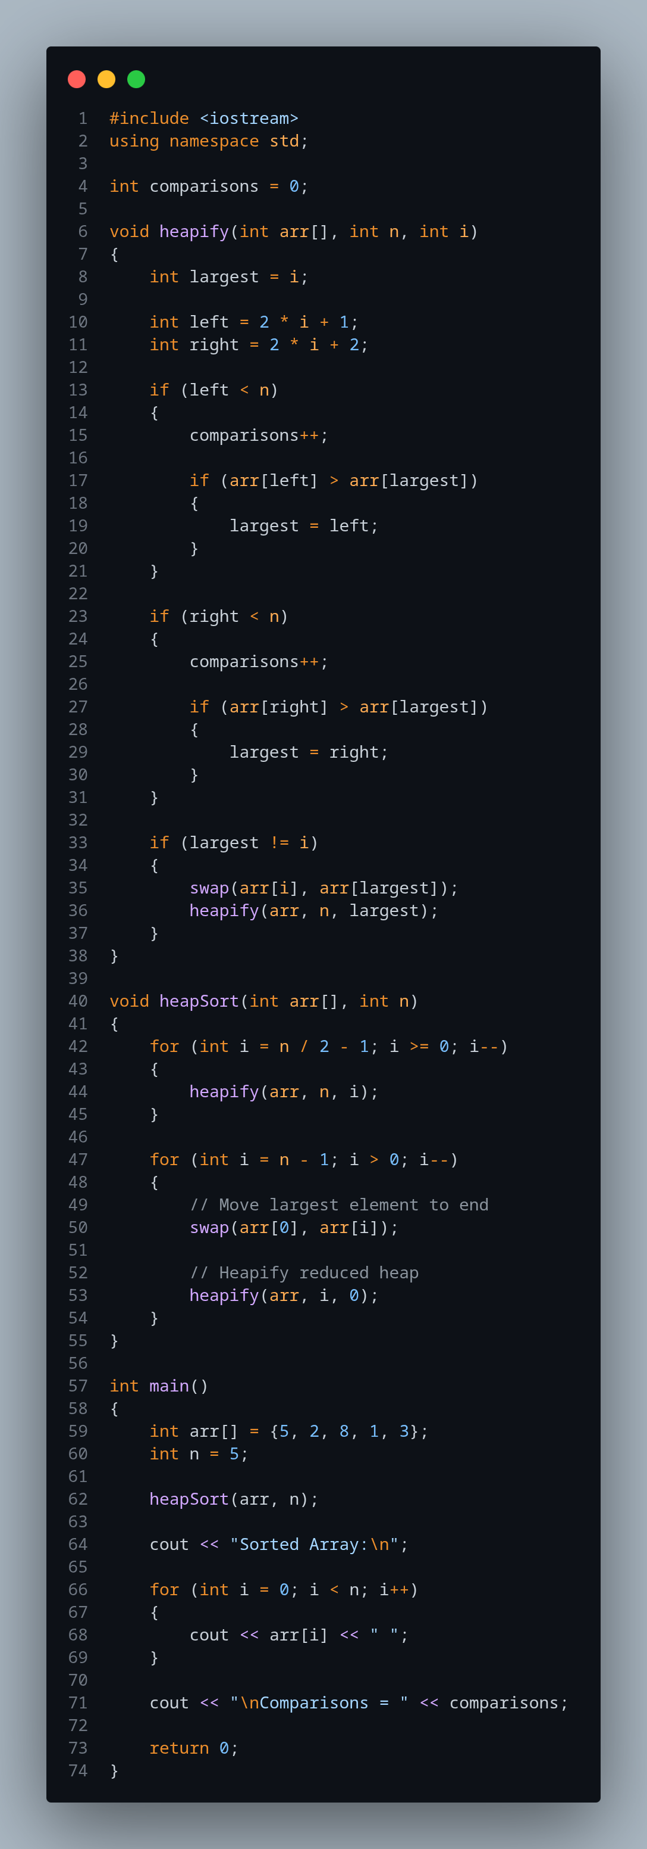

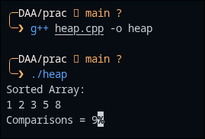

Q4) Write a program to sort the elements of an array using Quick Sort (The program
should report the number of comparisons).

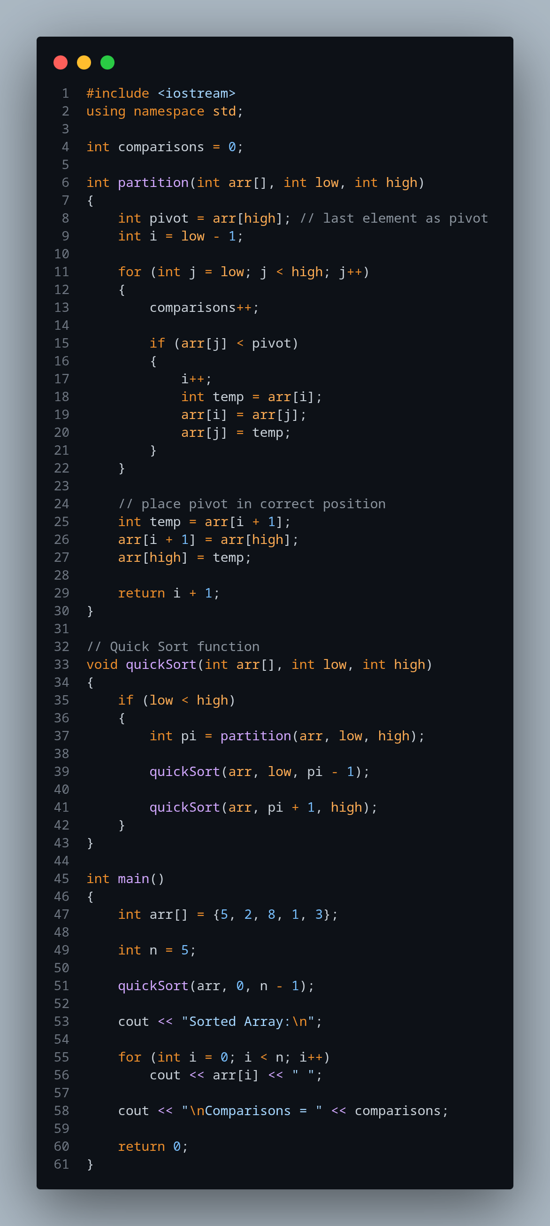

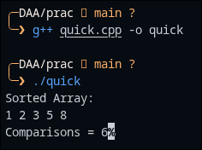

Q5) Write a program to multiply two matrices using the Strassen’s algorithm for matrix
multiplication.

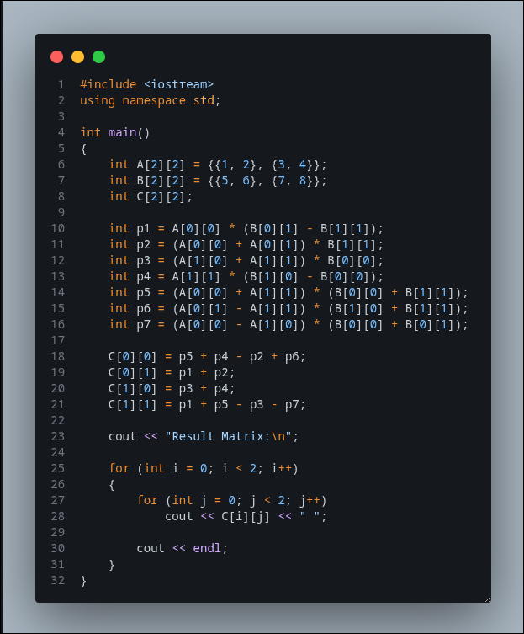

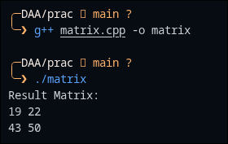

Q6) Write a program to sort the elements of an array using Count Sort..

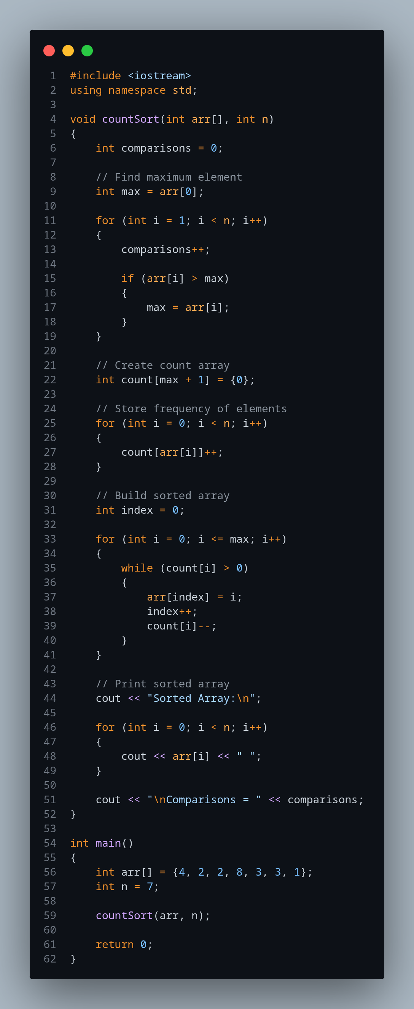

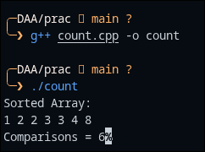

Q7) Display the data stored in a given graph using the Breadth-First Search algorithm.

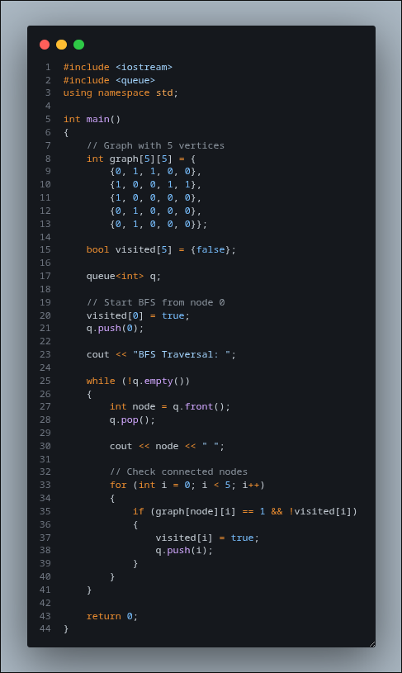

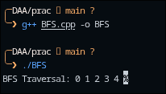

Q8) Display the data stored in a given graph using the Depth-First Search algorithm.

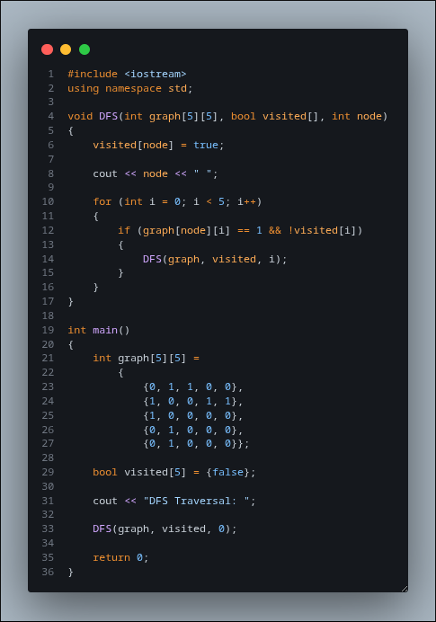

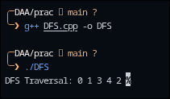

Q9) Write a program to determine a minimum spanning tree of a graph using the Prim’s
algorithm.

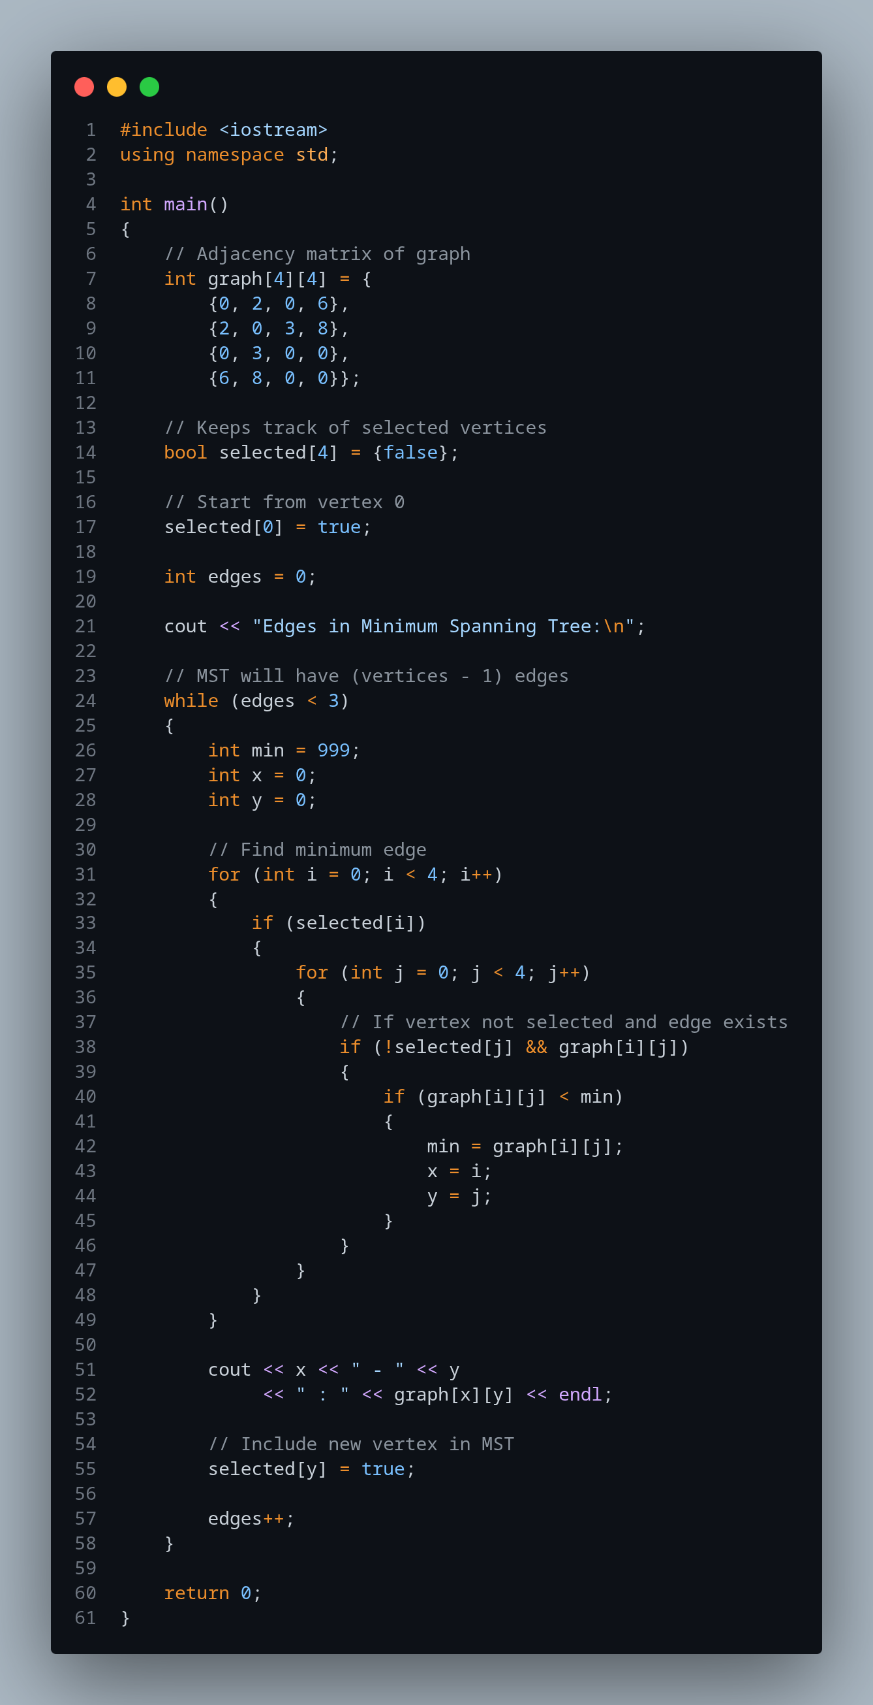

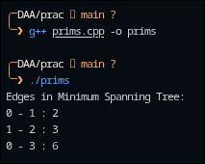

Q10) Write a program to solve the 0-1 knapsack problem.

